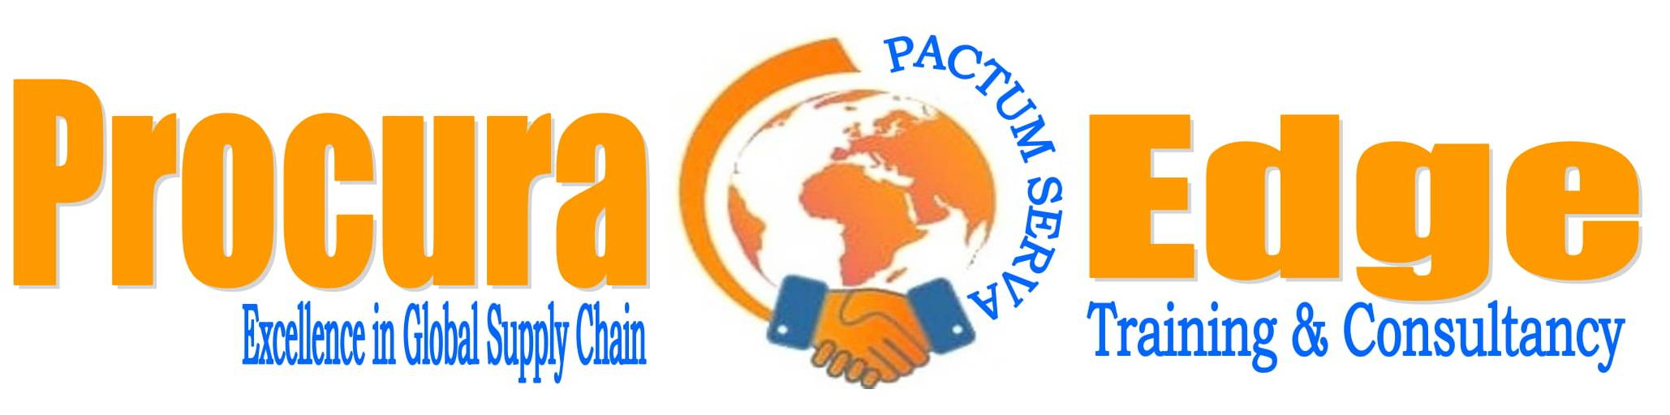
- ABOUT PROCURA EDGE (PE)

PE’s Professional Capacity Building Team sends you its heartfelt warm greetings, wishes for good health given these worrying times, and assures you that together we will soldier on. We will work hard and smart and ensure that we meet your needs remotely at high standard and with in-depth quality.

We drive organizational excellence across multiple sectors of economy with our on-board specialists in different functional areas and deliver cost reductions, deliver and maintain savings and improve our clients’ profitability. Our relentless focus on bottom-line results combined with our deep market knowledge ensures that spend is optimized and sustained.
We provide consultancy services that create value through strategic thinking, efficient processes, technology system integrations, being customer-centric and empowering people to think creatively for organizational excellence. We offer a range of professional services that drive step-changes in operational performance, increase margins and add value to organizations.

Our Vision
The pace setter in training and consultancy services value offerings world-wide by unlocking and developing organizational potential.

Our Mission and Objectives
Enabling our clients achieve their vision through provision of high-quality services.
Our key objective is to improve the operational effectiveness of our clients by developing solutions and building their internal capacity.

Core Values
Procura Edge (PE) strives to be an ethical role model by demonstrating standards that are essential for building a best in class organisations. These standards are defined in our corporate value system, and every practice within the PE is subject to review and quality control. Our values are:
• Inclusiveness and diversity through engaging local suppliers, and utilizing diverse and disadvantaged suppliers where possible.
• Integrity and transparency through ethical behavior, compliance with stated practices and policies, and communication of our goals and results.
• Effective stewardship through ongoing financial goal setting to deliver value, emphasizing vendors promoting sustainable products and operating in a manner which supports attainment of the PE financial objectives.
• High ethical standards in our service delivery.
• We believe that independence, objectivity, and full disclosure of material factors affecting findings and conclusions and up holding confidentiality of data and information provided is the key success factor for every assignment we undertake.
• We maintain high level of professional ethics, innovation, teamwork, discipline and excellence in service provision.

Our Management
We are committed to promoting high standards of discipline, excellence and ethics through adherence to the firm’s quality standards and value charter and the laws of the country and the profession. We believe in recruiting and retaining sound, professional and support staff, providing training and opportunities for growth in a stimulating and enabling environment.
We are dedicated to maintaining a strong internal administration, thereby enabling provision of quality service and ensuring client satisfaction. We believe relationships are our top priority, and we strongly believe that good relationships with our stakeholders are a pre-requisite to success.

Our Experts
PE has a powerful combination of a skilled team comprising of Supply Chain Management Consultants, Marketing Consultants, Economists, Statisticians, Human Resource Professionals IT Experts, Monitoring and Evaluation Experts, Accountants, Lawyers, Engineers, Project Managers. We aim at minimising risk, devising and implementing innovative client-based solutions that lead to the better utilization of resources and improved service delivery, and maximise value and opportunities for our clients.
Project teams are assembled to meet the specific and varying needs of each client’s project. For any project undertaken, we are able to bring in together expertise required in areas of project management, survey design, data collection and data analysis. Our approach to staffing is designed to meet internationally accepted professional standards. This enables us to provide highest level of professionalism for our clients. We are sure that you will receive the services you deserve from the PE team.

Our Strengths
Our competitive edge lies in our thought leadership, positive attitude and the unique approach we bring to the consultancy services we provide. Through forward thinking initiatives, we deliver sustainable solutions for the long term and seek to ensure our clients are prepared for the future. Our consultancy service is one such solution.

Knowledge of Public & Private Entities Operations
Over the years, we have had the opportunity to provide consultancy services with many organizations including local authorities, parastatals and private entities, providing various services across the country. We bring into each project what we have learned, customizing our approach to match the individual culture and dynamics of each client that we serve. Awarding the consultancy services to PE will enable your organisation to realize synergies from the experts, together resulting in improved deliver of the said service.

Course Design & Development Methodology
We at PE ensure that this process is based upon the value of pre-course research and by ensuring inclusion of all key stakeholders, therefore ensuring relevance and shared vision and ownership.

We analyze training needs by scrutinizing performance gaps and discrepancies given people differences, technology interplay and organizational environment.

We then plan a course design that determines how best the needs will be met by putting into consideration organizational priorities, process, procedures, costs, resources, and the nature of the learning involved.

We proceed to develop training objectives as informed by training needs analysis and design process. We understand that some objectives can best be met by means such as job aids, work experience, equipment adjustments, among others. The identified training needs require further analysis to determine how they might best be approached from a training point of view.

We thereafter develop customized training materials and training aids loaded with practical examples, questions and individual and group exercises, among others and deliver either online via webinars or on-site at location determined by the client.

Our Experts
PE has a powerful combination of a skilled team comprising of Supply Chain Management Consultants, Marketing Consultants, Economists, Statisticians, Human Resource Professionals IT Experts, Monitoring and Evaluation Experts, Accountants, Lawyers, Engineers, Project Managers. We aim at minimising risk, devising and implementing innovative client-based solutions that lead to the better utilization of resources and improved service delivery, and maximise value and opportunities for our clients.
Project teams are assembled to meet the specific and varying needs of each client’s project. For any project undertaken, we are able to bring in together expertise required in areas of project management, survey design, data collection and data analysis. Our approach to staffing is designed to meet internationally accepted professional standards. This enables us to provide highest level of professionalism for our clients. We are sure that you will receive the services you deserve from the PE team. Some of Our Experts include:

CHARLES KAMANDE MCIPS (UK), MKISM (K), SCM℗, Procurement & Supply Chain
Consultant

Charles has 18 years of procurement operations and supply chain management leadership. Teaching and consulting experience in both private and public procurement practice and has mentored many.

He has undertaken procurement research and policy making, procurement capacity building, procurement audit/ review with different organisations including Public Procurement Regulatory Authority of Kenya, World Bank, African Development Bank, German Technical Cooperation (GIZ), Deloitte Touché, Media Council of Kenya, Local Authorities Provident Fund, Kenya Institute of Supplies Management (KISM), Centre for Advanced Procurement Studies, Institutional Consultants (a division of Institute of Certified Public Secretaries), Kenya Union of Savings and Credit Cooperatives as a Consultant Trainer, County Governments of Turkana, Kakamega, Vihiga, Bungoma and Busia, Kenya Roads Board, Kenya National Highways Authority, Kenya Urban Roads Authority, Kenya Rural Roads Authority among others.
Charles has authored Study Manuals for KISM’s Certified Procurement & Supplies Practitioner of Kenya (CPSK) and is a Part-Time Lecturer and Resource Person at Kenya School of Government and Kenya Institute of Supplies Management (KISM).

DR. JOSEPH K NGERA MCIPS, MKISM, Procurement & Supply Chain Trainer

Joe Ngera has 13 years as a procurement and logistics professional with theoretical and practical experience in various operational and supply chain environments spanning the medical field, shipping, logistics and teaching both professionally and academically in the institutions of higher learning.
He is a specialist in international logistical planning and coordination, demand analysis and lean processes. He is adept at analyzing procurement and distribution procedures and systems, coordinating international trade and using best practices to implement more efficient processes and reduce working capital costs.
He has successfully prepared training and testing materials for the Masters and undergraduate students in supply chain management, and assisted teaching and preparing students enrolled for professional diploma course with Chartered Institute of Procurement and Supply (CIPS) from Level 3 to level 6.

JOE MUNORU FCIPS, CMCILT, PGCEi, TSC, CPSM, SCM, MKISM, Chartered Procurement & Supply Chain Trainer & Consultant.

Joe has 20 years of experience as a supply chain professional practitioner in both public and private sectors including 18 years of experience in classroom with African and Asian Supply Chains experience. He has successfully delivered as the Project Manager the research, design and development of Supply Chain Management needs analysis, tool kit and Methodologies in both Public and Private Sectors, that he now extends to Procura Edge (PE).

His consultancy work includes designing and presenting at supply chain management workshops both in Africa and Middle East, and has made many presentations for professional groups, universities professional associations among others. In teaching and corporate training world, Joe has designed and presented workshops for clients in public and private sectors, embracing subjects of broadly procurement, and management nature commercial skills, project management and partnering. His consultancy work includes analysis of business opportunities in the public and private sectors in supply chain and running seminars in all sectors of the economy.

Joe’s work dimension includes analysis of business opportunities in the public and private as well as non - profit making sectors with domain in Procurement and supply chain strategic management for several multinational and major local organizations in senior positions of decision making since 1994 to 2012 before venturing into full time Training and Consultancy. He has been teaching and consulting in Procurement and Supply Chain Management, Logistics and Projects & Programme management in institutions of higher learning and Professional Training Institutes locally, regionally and within the international spectrum.

Joe has authored Study Manuals for CIPS Level 5 and Level 6 and CILT Modules and is a regular Tutor and resource Person at Kenya School of Government and Kenya Institute of Supplies Management (KISM) and Leading Resource Person for the Professional training institutes in Bahrain, UAE and the Sultanate of Oman and regionally in Rwanda and Uganda and he is also a current examiner with many professional and academic institutions and universities.

MARTIN WANJOHI, Information Technology and Statistics Expert
Martin has 27 years of progressive experience in Public Financial Management, Public Policy and Management, Project management, Programme Life Cycle Management, Monitoring and Evaluation; Strategic Planning and Information Communication Technology. He holds a Master of Science Degree in Information Systems from the University of Nairobi, BSc (Hons) in Statistics, a certificate in Strategic Planning from Harvard Business School (USA), a Certified Public Accountant (CPA Kenya) and a Certified Information Systems Auditor (CISA).

KENNEDY AUKA, Financial Management Specialist
Kennedy has 27 years working experience in both private and public sector organizations handling operations management, procurement and logistics management, financial management, treasury management, risk management, strategic plan development and human resources management. He has undertaken several consultancy assignments in Kenya, Uganda, Malawi, Lesotho, Tanzania and Zambia which include designing and developing operations manuals for project implementation unit that include financial, accounting, procurement and human resource regulations. Other assignments in the public sector include procurement capacity assessment capacity for Kenya comprising 50 procuring entities in sampled sectors, financial management agent, institutional assessment, financial advisory services, and organizational development.

MARTIN KAHUMBURU, Economist and Budget Analyst
Martin has 36 years of experience in budgeting, statistics, economics, strategic planning and project management. He possesses a Bachelor of Philosophy in Economics, Bachelor of Science in Statistics and Master of Arts Degree in Economics. He is a Fellow of the Institute of Statisticians (FIS) – UK, after completing all examinations in both applied statistics, econometrics, economic and social statistics from the London School of Economics (UK), was awarded the Advanced Stage in Statistics (Distinction) Certificate by the Royal Society of Arts, and possesses the Highest Stage in Business Statistics (Distinction) from London Chamber of Commerce (LCC).

MARY GACHONDE, HR Specialist
Mary is a seasoned Human Resources (HR) specialist with 32 years of experience in both public and private sectors. Mary possesses a Master of Science in Human Resource Management from University of Manchester, UK; Bachelor of Arts (Social Sciences) from University of Nairobi, a Post Graduate Certificate in Training Management – WES College, Brugge, Belgium; and Several Certificates in Management and Human Resources Development including, Management Communication, Training of Trainers, Human Resource Audit (including benchmarking attachment on best practices in HR function in UK) Total Quality Management, Results Based Management, Policy Making and Policy Analysis and Computer Applications. On the automated HR system, Mary works hand in hand with Mr. Matthew Muteti, an IPPD specialist with 38 years’ experience with a Head of State Commendation for exemplary work and results delivery.

GEORGE K KAMAU, Legal Specialist
Mr. George Karuthui Kamau is an advocate of the High Court of Kenya with over 12 years of experience in the legal field. He holds a Chartered Institute of Procurement and Supply Diploma, possesses a Bachelor of Laws degree and was admitted to the bar in 2007. He has a bias in public procurement and assets disposal, and has represented Procuring Entities at the Public Procurement Administrative Review Board.

Forward Thinking
We deliver sustainable solutions for the long term and seek to ensure our clients are prepared for the future. Our vision is heavily skewed to the future, with emphasis to strong foundations in the present. We seek to assist our clients set foundations that will serve them diligently into the future.
Our Promise
We undertake to passionately deliver to you with cost effective and high-quality Training and consultancy services. We will keep up with your changing needs, by being dynamic and continuously evolving our systems and practices.

Payment for Services

Payments should be made to either our back account:

Or via MPESA Pay bill No.:

By indicating the Item Code, Course Code or Program Code

Terms of payment: 10% Down payment. Balance to be paid in 30 days.

- CIPS – UK QUALIFICATIONS
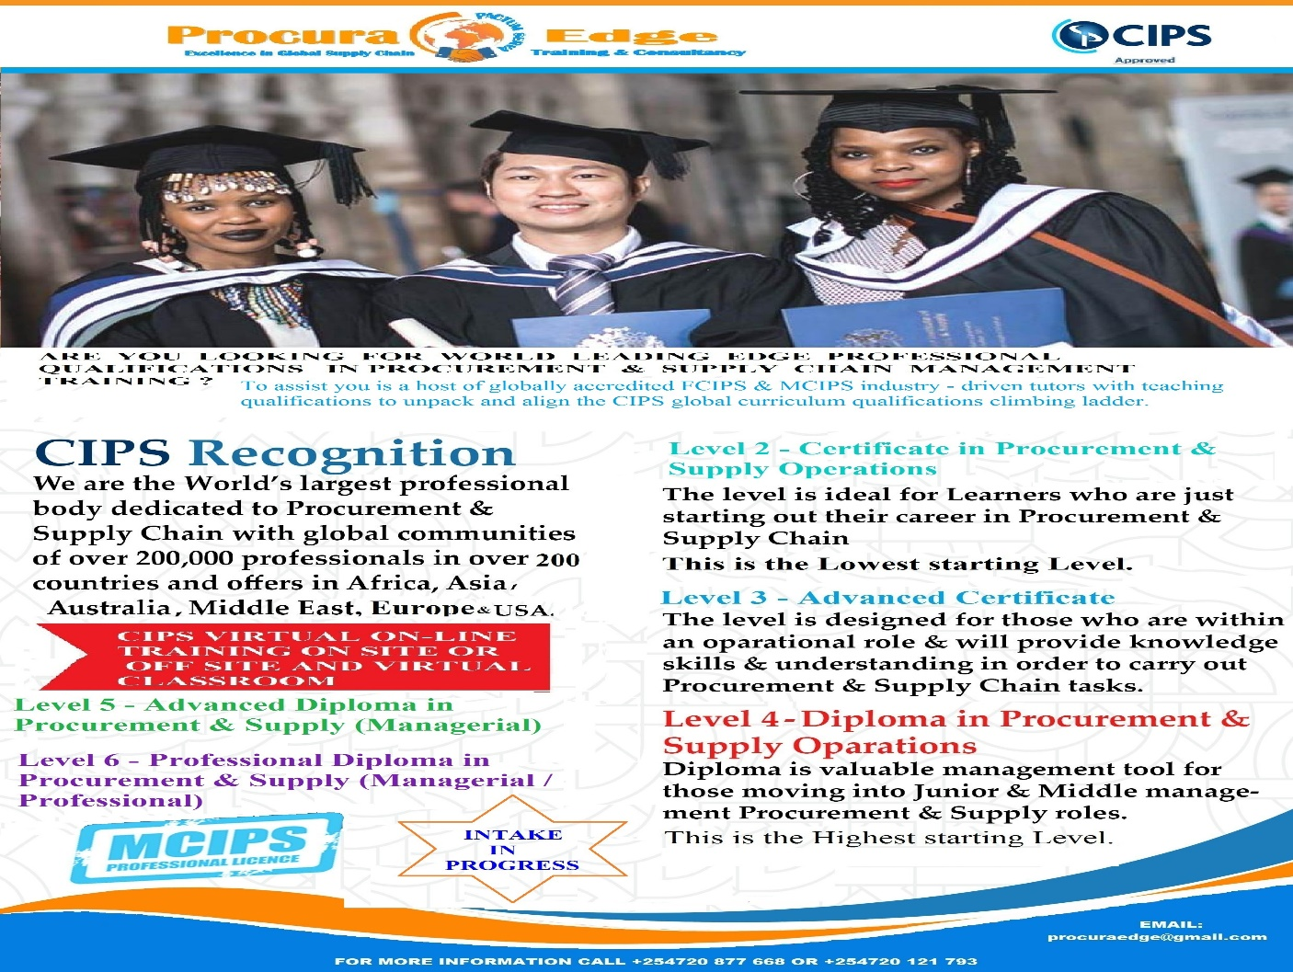

Procura Edge is a CIPS Approved Centre and CILT Training Provider in Kenya. We are passionate about growing a sustainable world-class, exciting, market focused curriculum with reliable, global delivery capacity, we aim to provide a globally relevant, easily accessible curriculum that meets current and emerging needs of organisations, procurement professionals, aspirant professionals and other professionals operating with the procurement and supply chain space.

It is on this premise that, as everyone is "locked out" of the office and working from home at the moment, that we will endeavour to provide the next cohort with necessary support for the upcoming CIPS exit exams.

CIPS Level 2 Certificate in Procurement and Supply Operations:
The first of CIPS’ three entry level qualifications*. It is ideal for those starting their career or if procurement and supply is part of their role or for those with little or no business experience and aspiring to move into a career in procurement and supply.
This qualification can also assist managers in other profession, business leaders or entrepreneurs understand how procurement should function and its overall impact on business success. This level has five core units.
* Refers to levels within the United Kingdom Regulated Qualifications Framework. Other regulatory bodies may have different corresponding levels.

CIPS Level 3 Advanced Certificate in Procurement and Supply Operations:
The second of CIPS’ three entry level qualifications. It helps one to prepare for a career in procurement and supply and progress onto the CIPS Level 4 Diploma in Procurement and Supply. One has four core modules to complete then choose one elective module.

CIPS Level 4 Diploma in Procurement and Supply:
The third of CIPS’ three entry level qualifications. Level 4 Diploma in Procurement and Supply has eight core modules. It is based on the operational and managerial levels of CIPS Global Standard. A candidate has to start on L4M1 Scope and Influence of Procurement and Supply and finish on L4M8 Procurement and Supply in Practice. The other modules can be done in any order.

CIPS Level 5 Advanced Diploma in Procurement and Supply:
Level 5 Advanced Diploma in Procurement and Supply is based on the managerial and professional levels of CIPS Global Standard, and will help you to gather confidence, improve procurement function’s output and fulfill organizational objectives.

CIPS Level 6 Professional Diploma in Procurement and Supply:
Level 6 Professional Diploma in Procurement and Supply leads one into becoming MCIPS. CIPS Level 6 Qualification builds on the knowledge and skills learned at the CIPS Level 5 Advanced Diploma in Procurement and Supply. A candidate is required to complete four core modules then select three elective modules.

CODE | QUALIFICATION | HOURS | COST (KSHS)
ENTRY LEVEL: LEVEL 2 CERTIFICATE IN PROCUREMENT & SUPPLY OPERATIONS
PE-L2M1 | Introducing Procurement and Supply (Core) – 6 Credits** | 60 | 6,000.00
PE-L2M2 | Procurement & Supply Operations (Core) – 3 Credits | 30 | 5,000.00
PE-L2M3 | Stakeholder Relationships (Core) – 3 Credits | 30 | 5,000.00
PE-L2M4 | Systems Technology (Core) – 3 Credits | 30 | 5,000.00
PE-L2M5 | Inventory, Logistics and Expediting (Core) – 3 Credits | 30 | 5,000.00
DISCOUNTED PRICE FOR THE WHOLE LEVEL 2 AS A PACKAGE |  |  | 25,000.00
CIPS LEVEL 3: ADVANCED CERTIFICATE IN PROCUREMENT AND SUPPLY OPERATIONS
PE-L3M1 | Procurement & Supply Environments (Core) – 6 Credits | 60 | 6,000.00
PE-L3M2 | Ethical Procurement & Supply (Core) – 6 Credits | 60 | 6,000.00
PE-L3M3 | Contract Administration (Core) – 6 Credits | 60 | 6,000.00
PE-L3M4 | Team Dynamics & Change (Core) – 6 Credits | 60 | 6,000.00
 | ADVANCED CERTIFICATE ELECTIVES (CHOOSE ANY ONE)
PE-L3M5 | Socially Responsible Procurement (Elective) – 6 Credits | 60 | 6,000.00
PE-L3M6 | Socially Responsible Warehousing & Distribution (Elective) – 6 Credits | 60 | 6,000.00
DISCOUNTED PRICE FOR THE WHOLE LEVEL 3 AS A PACKAGE |  |  | 28,000.00
DIPLOMA - Total qualification time (TQT) = 600 hours: Guided learning hours (GLH) = 250 hours
Self-study requirement (SSR) = 335 hours, Assessment time = 15 hours
PE-L4M1 | Scope and Influence of Procurement & Supply (Core) – 12 Credits | 120 | 8,000.00
PE-L4M2 | Defining Business Need (Core) – 6 Credits | 60 | 6,000.00
PE-L4M3 | Commercial Contracting (Core) – 6 Credits | 60 | 6,000.00
PE-L4M4 | Ethical and Responsible Sourcing (Core) – 6 credits | 60 | 6,000.00
PE-L4M5 | Commercial Negotiation (Core) – 6 Credits | 60 | 6,000.00
PE-L4M6 | Supplier Relationships (Core) – 6 Credits | 60 | 6,000.00
PE-L4M7 | Whole Life Asset Management (Core) – 6 Credits | 60 | 6,000.00
PE-L4M8 | Procurement and supply in Practice (Core) – 12 Credits | 120 | 8,000.00
DISCOUNTED PRICE FOR THE WHOLE DIPLOMA AS A PACKAGE |  |  | 45,000.00
ADVANCED DIPLOMA - Total qualification time (TQT) = 600 hours: Guided learning hours (GLH) = 250 hours, Self-study requirement (SSR) = 335 hours, Assessment time = 15 hours
PE-L5M1 | Managing Teams and Individuals (Core) – 12 Credits | 120 | 8,000.00
PE-L5M2 | Managing Supply Chain Risk (Core) – 6 Credits | 60 | 6,000.00
PE-L5M3 | Managing Contractual Risk (Core) – 6 Credits | 60 | 6,000.00
PE-L5M4 | Advanced Contract & Financial  Management (Core) – 12 Credits | 120 | 8,000.00
PE-L5M5 | Managing Ethical Procurement and Supply (Core) – 6 Credits | 60 | 6,000.00
 | ADVANCED DIPLOMA ELECTIVES (CHOOSE ANY THREE)
PE-L5M6 | Category Management (Elective) – 6 Credits | 60 | 6,000.00
PE-L5M7 | Achieving Competitive Advantage through the Supply Chain (Elective) – 6 Credits | 60 | 6,000.00
PE-L5M8 | Project and Change Management (Elective) – 6 Credits | 60 | 6,000.00
PE-L5M9 | Operations Management (Elective) – 6 Credits | 60 | 6,000.00
PE-L5M10 | Logistics Management (Elective) – 6 Credits | 60 | 6,000.00
PE-L5M11 | Advanced Negotiation (Elective) – 6 Credits | 60 | 6,000.00
DISCOUNTED PRICE FOR THE WHOLE ADVANCED DIPLOMA AS A PACKAGE |  |  | 48,000.00
PROFESSIONAL DIPLOMA - Total qualification time (TQT) = 600 hours: Guided learning hours (GLH) = 250 hours, Self-study requirement (SSR) = 335 hours, Assessment time = 15 hours
PE-L6M1 | Strategic Ethical Leadership (Core) – 12 Credits | 120 | 8,000.00
PE-L6M2 | Global Commercial Strategy (Core) – 12 Credits | 120 | 8,000.00
PE-L6M3 | Global Strategic Supply Chain  Management (Core) – 12 Credits | 120 | 8,000.00
PE-L6M4 | Future Strategic Challenges (Core) – 6 Credits | 60 | 8,000.00
 | PROFESSIONAL DIPLOMA ELECTIVES (CHOOSE ANY THREE)
PE-L6M5 | Strategic Programme Leadership (Elective) - 6 Credits | 60 | 8,000.00
PE-L6M7 | Commercial Data Management (Elective) - 6 Credits | 60 | 8,000.00
PE-L6M8 | Innovation in Procurement and Supply (Elective) - 6 Credits | 60 | 8,000.00
PE-L6M9 | Supply Network Design (Elective) - 6 Credits | 60 | 8,000.00
PE-L6M10 | Global Logistics strategy (Elective) - 6 Credits | 60 | 8,000.00
DISCOUNTED PRICE FOR THE WHOLE PROFESSIONAL DIPLOMA AS A PACKAGE |  |  | 50,000.00

**Credits are a way of quantifying the number of study hours needed to complete a qualification. 1 credit is equivalent to 10 hours of study.

Our CIPS Fastrack Ladder to MCIPS:

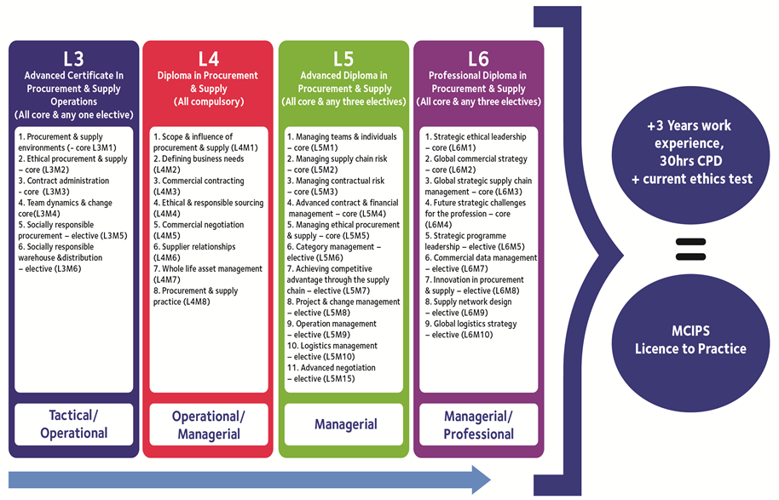
An innovative approach to learning from some of the world's leading-edge procurement trainers

- PROCUREMENT CONSULTING
PE provides high-quality training and consultancy services in Procurement Research, Procurement Advice and Policy, Logistics Management, Stores & Warehousing Management, Procurement Audit, and Supply Chain Capacity Building Consulting Services to public and private sectors globally. We partner with our clients to identify project objectives and develop practical straight forward solutions.

- Procurement Training Consultancy Services
PE undertakes both Online (virtual & webinar based) and Onsite interactive strategic and operational World Class Supply Chain Management Capacity Building Programs. PE is dedicated to assisting professionals in different functions in both the public and request private sector to acquire the knowledge, skills and attitudes necessary to move their supply chain management function to World Class 'leading practice' standards. Our clients are also at liberty to request tailor-made programs. Currently we are offering the following courses:
COURSE CODE | COURSE | SHORT COURSE DESCRIPTION | COURSE DURATION
PE-01 | Fundamentals of World Class Procurement | The course will enable the participant to gain a broader, practical understanding of procurement principles, processes and practices. It is an excellent way to prepare for later skills development in more advanced world-class Procurement topics. | 5 days
PE-02 | Procurement and Disposal Policy & Strategy Development | The participant will internalize on how to develop  World-Class procurement, disposal and contracting  policies, and procurement strategies. The  participant will also be exposed to a choice of  procurement methods, consultant selection  methods, specially permitted procedures and  financing options. The transparent will be in a  position to transform the procurement function and achieve the recognition it deserves through  implementing the vision of a world-class  procurement organization. | 5 days
PE-03 | Overview of the Public Procurement & Disposal Act, 2015 and Regulations 2020 | The Course will provide you with an overview of the Act and the Regulations including oversight, procurement and disposal rules, processes, methods, among others | 3 days
PE-04 | Budgeting & Procurement Planning | Budgeted and approved procurements lead to supply chain management efficiency, and achievement of value for money. This Course will expose the participants to how funds are budgeted for and planned, needs identified, consolidating department requirements; categorizing procurement, lot sizing, estimating market prices and costs of goods, work, services and consultancies, time scheduling, managing Total Cost of Ownership, procurement monitoring and updates, and statutory reporting. | 3 days
PE-05 | Procurement Organization, Rules & Processes | This Course will expose the Participant on how the procurement function can be structured, its reportage, the rules to be observed and the procurement processes. | 4 days
PE-06 | Procurement Methods & Threshold Matrices | The participant will appreciate and gain skills on Open tender, Two-stage tendering, Design competition, Restricted tendering, Direct procurement, Competitive negotiation, Request for proposals, Force account, E-reverse auction, Framework agreements and contracts, Request for quotation, Community participation, Low value procurement, and Specially Permitted Procurement Procedures; and their Threshold Matrices | 5 days
PE-07 | Preparation of Specifications, Evaluation Criteria, and Evaluation of Bids Bidding Documents for Goods, Works and Non-Consulting Services | The participant will be able to prepare tender documents for goods, works and services; create tender specifications that are clear, correct, complete, concise, and unbiased, set eligibility criteria, evaluation criteria, qualification criteria and award criteria; effectively evaluate tenders for goods, works and services; undertake contract negotiation; preparation of evaluation reports; write a professional opinion; and comprehend how award decisions are arrived at | 5 days
PE-08 | Preparation of Terms of Reference, Evaluation Criteria, and Evaluation of Proposals | The participant will be able to prepare tender documents for consultancy services; create terms of reference that are clear, correct, complete, concise, and unbiased, set eligibility criteria, evaluation criteria, qualification criteria and award criteria; effectively evaluate proposals; undertake contract negotiation; preparation of evaluation reports; write a professional opinion; and comprehend how award decisions are arrived at | 5 days
PE-09 | Negotiation in Procurement | Procurement Professionals negotiate more often than anyone else in the organization. This course will enable the participant gain a broader understanding of the negotiation process, its key stages and how it adds value. | 5 days
PE-10 | Legal Aspects in Procurement & Supply Management | Many legal processes apply to the procurement environment. The participant will be able to brush up on this crucial component in procurement. | 2 days
PE-11 | Global Procurement | This course will enable the participant understand global strategic procurement processes including: supplier identification, supplier segmentation, supplier relationship management and development, market survey assessment, supplier evaluation and  selection, category management, stakeholder engagement; total cost of ownership; measurement  of supply chain performance, international logistics, Incoterms and documentation; contract negotiation tactics; and procurement contracts and agreements. | 5 days
PE-12 | Managing Supply Chain Risks | At the end of the course, the participant will appreciate about Protection of Personal Information (POPI); Manage conflicts within the Supply Chain by settling differences, working constructively and collaborating as individuals and groups with a common purpose; Ensure procurement performance; uphold professional ethics and standards; detect, prevent and investigate procurement fraud; manage procurement processes, reporting and contract management by identifying, analyzing and managing risk in Procurement and Supply; and preparing for procurement audit/ review | 5 days
PE-13 | Procurement Assessment, Review & Audit | This course will expose the participant into the differences between procurement and contracts assessment, procurement audit/ review and procurement investigations by addressing procurement process audit, contracts audit, value for money, performance audit, procurement systems audit, procurement monitoring and evaluation, and procurement audit reporting. | 4 days
PE-14 | Developing and Managing Contracts and Service Level Agreements | This course will enlighten the participant on how to minimize risks in dealing with suppliers while developing, entering and managing contracts for goods, works, non-consulting services and consulting services. | 5 days
PE-15 | MS Excel for Excellent Procurement Performance | The participant will be in a position to leverage and exploit Excel tools in your Supply Chain Management analysis and reporting | 5 days
PE-16 | Integrated Asset & Disposal Management | The participant will gain experience in Disposal Planning, Asset management (maximizing usage, maintenance and repair, and maintaining asset registers); and Disposal management (including preparation of disposal tenders) | 5 days
PE-17 | Procurement Category Management, & Supplier Management & Development | The participant will be exposed to procurement category management and strategies, Supplier Development, and Supplier Relationship Management. | 4 days
PE-18 | Logistics Management | It is crucial to use resources effectively and minimize non value-adding movement of goods in the supply chain. The participant will internalize on Physical Distribution Management (both in-bound and out-bound) | 3 days
PE-19 | Project Management for Procurement Professionals | A practical approach to establishing a project organization and managing projects in the Procurement environment using project management tools such as Prince I and Prince II | 4 days
PE-20 | Preferential Procurement & Reservations | This course will dwell on Purpose of Preferences & Reservations (P&R) Schemes, their Applicability, Registrations & benefits of registering with Access to Government Procurement Opportunities (AGPO), Types of Preferences & Reservations, Target Groups Implementation of P&R and related enterprise development | 3 days
PE-21 | Procurement Management, Ethics, Professionalism, Influence & Leadership | Are you an efficient, effective and respected leader in your procurement or supply chain environment? Learn how to motivate and support supply chain members and stakeholders in achieving objectives, maximize the potential of your organization through effective leadership in a variety of contexts, including through change, adversity, conflict and success. Settle differences, work constructively and collaborate as individuals and groups with a common purpose. Avoid and manage the ethical 'traps and pitfalls' within the supply chain. Overcome challenges, monitor, influence procurement practice, manage and lead modern procurement functions by being a professional, and ethical. | 5 days
PE-22 | Fundamentals of Stock Control and Stores Management | Effective and efficient stores management are crucial to an organization. The purpose of this program is to introduce the participant in the line of Stores Clerk, Warehousing Staff, Stores Supervisor and Manage to the concepts of essentials stock control and management and develop the learner to accept responsibility through understanding the requirements and obligations of the stores function by implementing essential stores management tools | 5 days
PE-23 | Operations Management for the Procurement Professional | We will guide you on Value Analysis and Value Engineering so that you create more value in your supply chain. We will show you how to sell Procurement Business Cases, identify and diagnose customer-critical business issues and create a desire within the customer for a procurement solution. We will help you craft Procurement Communication Intelligence both internally and externally. We will chaperon you on Procurement Time Management (including improving planning, assertiveness, decision-making, desk management for greater productivity). We will also ensure that you understand and appreciate benefits of costing, inventory and planning in supply chain processes. | 5 days
PE-24 | Bidding to Win (for Suppliers) | The potential and the existing suppliers will understand and appreciate the bid preparation process, the evaluation process, enhance bidding knowledge and skills, appreciate their Rights as Bidders, understand their obligations; appreciate the common pitfalls; and appreciate the Preference & Reservations Schemes and how they apply to them | 2 days
PE-25 | Advanced Inventory management, Warehousing Operations & Management | Cost pressures and complex supply chains require a minimum of cash tied up in inventory while satisfying the customer to the maximum. Warehouse operations and management is a key area where competitive advantage can be gained and exploited. We will offer you step-by-step implementation guidelines on how to lower costs, effectively and efficiently manage warehouses and achieve business goals. | 5 days

- Procurement Research: We undertake empirical research in procurement market research, supply market analysis, procurement, supply chain, inventory & warehousing management, and contracts management.
- Procurement Consulting: We work together with our clients in developing procurement policy; strategy; procurement and disposal manuals; developing procurement plans; preparing bid documents; supply chain management; logistics management; value for money analysis and value chain analysis; public-private partnerships procurement assessments, audits, reviews and investigations; procurement agency; and advising bidders on bidding and appeals.

- OTHER CONSULTING SERVICES
PE also provides high-quality training and consultancy services in:
- Research: We provide market research and surveys, business environment surveys, customer satisfaction surveys, employee satisfaction surveys, and work environment surveys.
- Program & Projects management: We assist in projects formulation, project feasibility studies, work-planning and budgeting, projects monitoring, projects evaluation and projects supervision.
- Financial Consulting: We add value by undertaking results-based budgeting, developing financial systems, financial advisory services, fiduciary risk assessment, financial audit,
- We also consult in Credit Management, Marketing Management, Information Technology, Statistical Services, Legal services, and Human Resources Management among others

- OUR PARTNERS

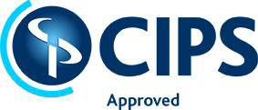
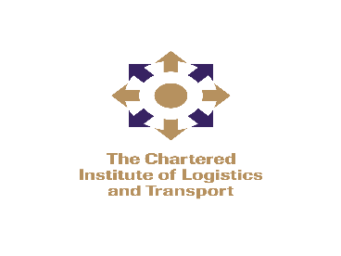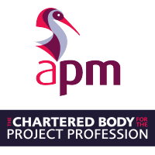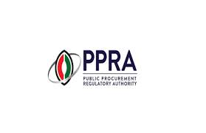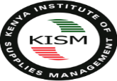
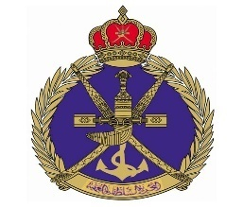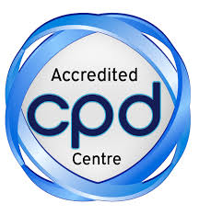


- PICTORIALS

- DOWNLOADS.>>>>. Consider online Registration
Program/ Course Registration Form

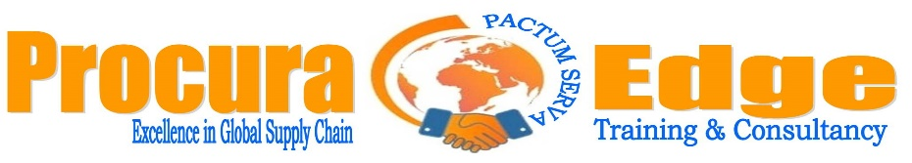

COURSE/ PROGRAM CODE: ……………………………......……………………………......

PROGRAM/ COURSE TITLE: …………………......………………………………………......

ORGANIZATION INFORMATION
Organization: ……………………………………….......................................................................
Postal Address: ……………………………………… Code……………………………………… Landline: ………………………………………………... Mobile Tel.: …….………………...
E-mail: …………………………………………………...................……………………….
Organization PIN Number: ………………………………………………………………
Name of Authorizing Officer: …………………….............…………………………………….......
Designation: ……………………………………......... Signature: ……….........………………….
Name of Officer to address the invoice: ………......………………...……....................................
Designation: ………………………………………………………...……………………............
Organization Stamp for confirmation: ………………………......................................................
PARTICIPANTS DETAILS
NAME | DESIGNATION | E-MAIL | TELEPHONE

TICK MODE OF PAYMENT
- Bankers Cheques
- Electronic Transfer
- M-PESA Pay Bill
Bank Account Name | Procura Edge Ltd
Bank Account Number | KES –  USD -
Bank Name
Bank Branch
Branch Code
Swift Code
Vat No
PIN No.
M-PESA Pay Bill No.

For M-PESA pay bill option, put your name and organization as account number without spacing. Dully filled forms should be e-mailed to procuraedge@gmail.com
Terms of payment: 25% Down payment as commitment. Balance to be paid in 30 days

- OUR CONTACTS
Website: www.procuraedge.org
Postal Address: P.O BOX 17843, NAIROBI 00100 GPO
Tel: +254 720 877 668, +254 720 121 793
EMAIL: procuraedge@gmail.com

Copyright ©2020 Procura Edge Ltd

